Alexander Baldree
1-13-26
Module 1.1 Assignment
CSD340

#72 Some Emotions May Be Universal
Summary:
This principle explains that certain emotions, such as happiness, fear, anger, sadness, surprise, and disgust; are experienced similarly across cultures. Because these emotions are universally recognizable, designers can leverage emotional cues like facial expressions, color, and imagery to communicate meaning quickly and effectively in digital interfaces.

Embellishment:
What the reading does not fully explore is how micro-emotions influence user trust and comfort in web design. Subtle emotional signals, such as friendly illustrations, warm color palettes, or empathetic micro-copy; can help users feel safe and understood, especially in high-stress situations like checkout pages, error messages, or account recovery screens. For example, a calm tone paired with soft visuals during an error state can reduce frustration and prevent users from abandoning a task. Emotional universality gives designers a powerful tool to communicate reassurance without relying heavily on language, which is especially important for global websites.

Visual Example:
A strong example can be seen in Mailchimp’s interface, which uses friendly illustrations and a playful tone to evoke positive emotions and reduce anxiety during tasks like campaign creation or error correction. Visual reference: https://mailchimp.com/

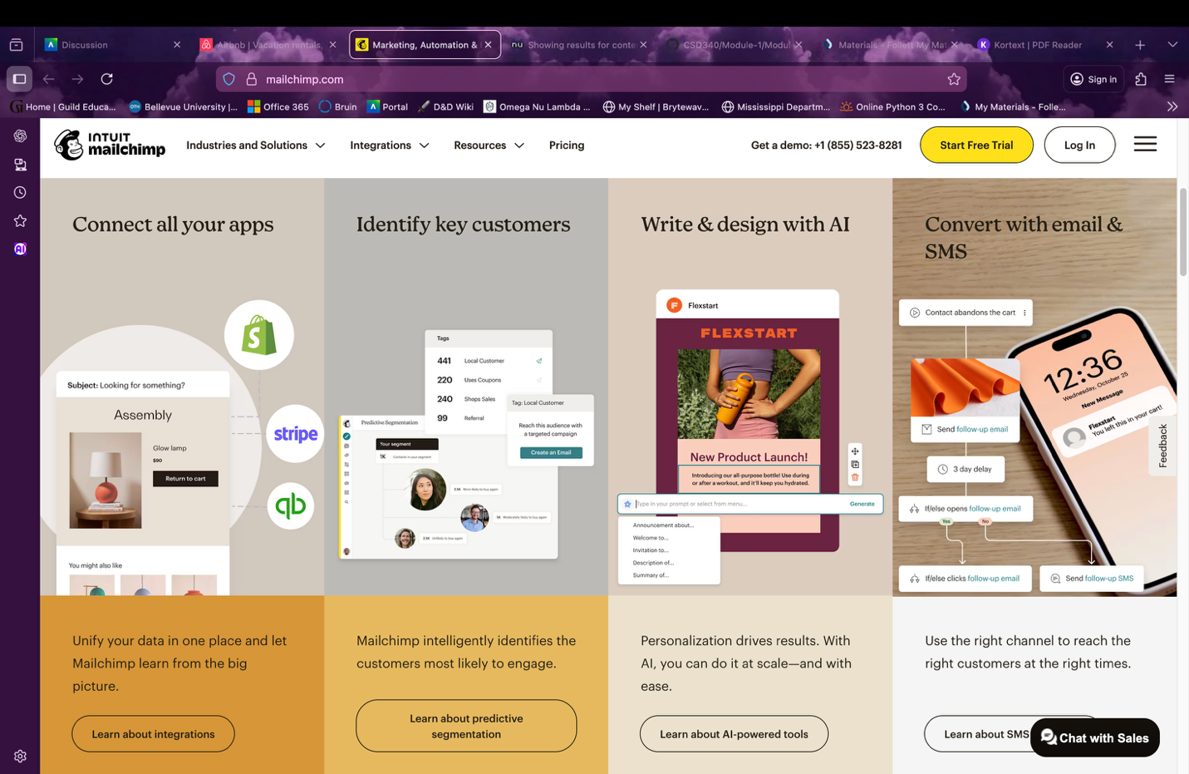

#75 If People Can’t Feel, Then They Can’t Decide
Summary:
This principle emphasizes that emotion is essential to decision-making. People do not make choices based purely on logic; emotions guide preferences, priorities, and actions. Without emotional engagement, users struggle to decide what to do next.

Embellishment:
An important extension of this idea is the role of emotion in call-to-action (CTA) design. CTAs that appeal to emotion, such as “Get Started,” “Join the Community,” or “Feel Secure Today”; often outperform purely functional labels. Emotional framing reduces uncertainty and motivates action. Designers must balance emotion with clarity to avoid manipulation, but when used ethically, emotional cues help users feel confident in their decisions and progress naturally through an interface.

Visual Example:
A clear example is Airbnb’s booking flow, which uses inviting imagery, human-centered language, and emotional storytelling to help users feel comfortable committing to a reservation.
Visual reference: https://www.airbnb.com/
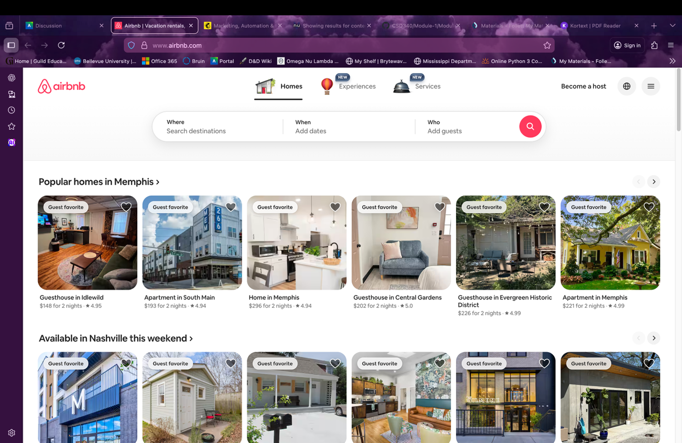

Conclusion:
These principles show that emotion is not an accessory in web design; it is foundational. By acknowledging universal emotions and designing for emotional engagement, designers help users feel understood, confident, and empowered to make decisions.

References:
100 Things Every Designer Should Know About People, Susan M. Weinschenk, Ph.D. Second Edition Pg.166-168 and Pg. 171-172

https://www.airbnb.com/ Visited 1-13-26
image of homepage

https://mailchimp.com/ Visited 1-13-26
image of homepage

